Working Trigger:

Trigger 1: Update Order Items for Orders table

The Trigger work once a user hit the checkout button- a new orders will be recorded, and the data will move from shopping cart to order detail, the data of the shopping cart then be removed permanently.

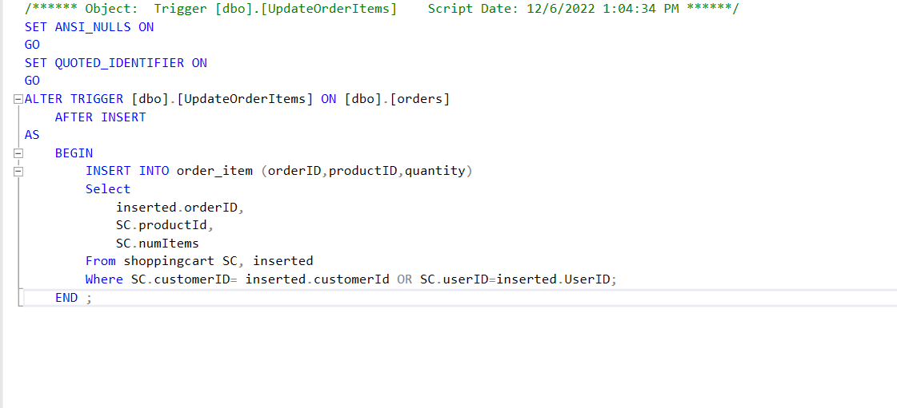

Checkout Form: The item was from querying of data from shopping cart

